Patricia Redondo

Professor Gahler

English 110

27 November 2018

Garbage Pollution in the Ocean - OP-ED

Our planet is made up of 70 percent ocean and 30 percent land. We as humans are on the top of the food chain and we create many items that are useful for our society. One of the things we have made is plastic. Plastic bags, plastic bottles, etc. Just like we make things, we throw it out. But where does all this garbage go? Into the ocean. Trash in the ocean is a form of pollution, and this is becoming a national outcry. Because we produce so much waste, that waste finds its way to the ocean and other forms of bodies of water such as rivers, lakes and deltas. How do we expect mother nature to protect us if we don’t protect her?

Most of the trash that consumes our oceans are plastics, this is because plastic does not easily break down, especially in water. When plastic is on land, it can be heated and broken down a little bit faster and easier. But when plastic is in the ocean it is cooled down by the water. It finds a new home where it is coated by algae which shields the burning rays of the sun causing plastics to stay well put polluting our oceans. Most marine pollution comes from land about 80 percent of the time, and the other 20 percent comes from ships at sea.

The Great pacific garbage patch located between Hawaii and California, is a large area in the Pacific Ocean purely made up of trash. This garbage patch came to be as oceanic currents that contain an immense amount of debris and trash crash against one another, piling all the garbage in one area. The actual size of this garbage path is unknown due to its constant growth. Studies have been done to know what type of trash mainly consumes the great pacific garbage patch and it was learned that 90 percent of the trash there is indeed plastic. A major contributor to this catastrophe is dumping. Dumping is when all the deposits and waste materials from industries, factories, ships, tankers and sewage throw their waste into the sea. Some of these materials created by these corporations contain materials such as mercury, cryolite, DDT and even radioactive materials which produce negative effects for the environment.

This immense amount of trash that consumes our oceans not only affects us, but it affects that wildlife that inhabits it. This presence of plastic and trash has a significant impact on the wildlife. This includes all life from big to small; whales, birds, turtles, plants. Animals can easily be snatched by nets and six pack rings around their necks. Animals are endangered of choking on all kinds of objects such as straws, plastic wraps, etc. Many of these animal mistake brightly covered trash for food which will harm them in the process. These chemically produced substances contain toxins and poison that will be passed onto the sea animals when they consume them. Scientists have recently discovered that pharmaceuticals that we humans ingest but do not fully digest in our bodies is ending up in the fish and marine life we eat. We are what we eat.

In October of 2006, the U.S. government created the Northwestern Hawaiian Islands Marine Monument. The northwest of Hawaii frequently meets the Great Pacific Garbage Patch. After the Marine Monument was created, Congress passed a legislation to increase the funding for the cleanup of this landfill in the ocean. They also encouraged other government agencies to expand their cleanup work as well. This is a very important and necessary step to inform and encourage more government attention to such a big problem. It is important for the government to take extra precautions to save our earth and prevent more trash from infesting the oceans and seas.

Although the Northwestern Hawaiian Islands Marine Monument has given slight attention to the problem, we still must do more to prevent more trash from polluting our oceans. If we continue, who knows what the future will look like. A great effort that is being done is recycling. It is helping to reuse the plastics and papers that we use to either reuse them or to convert them into something useful such as tote bags, pencil cases, etc. But a lot more must still be done. Laws must be developed to prohibit dumping at sea and to do something about the untreated sewage also being allowed to flow into the ocean.

Another form of marine pollution are the oil spills from tankers and offshore rigs. Accidents that occur from oil spills from tanker ships have shown us the extent of the damages that these sorts of spills can do to the ecosystems. Not only do the local areas where these spills happened get affected, but the animals who lived in those areas also become affected because their homes have become infested. Oil in the skins of animals can be very dangerous. Oil spills release toxins into the ocean, they prevent the sun from entering through the ocean preventing the marine life from getting sunlight and take the oxygen from the ocean making it impossible for the marine life to respirate. This is all happening right now all over the world, and we must attend to it now before it is to late.

Redondo Patricia

Professor Gahler

English 110

27 November 2018

Garbage Pollution in the Ocean – Photo Essay

Imagine sitting on a beach listening to the sound of the waves as they crash onto the shore. Seeing the rays of the sun glisten on the surface of the ocean like diamonds as it warms the water. Now what if you open your eyes and see trash all over the shore and floating all over the water. This is a horrifying site that is becoming a reality. The pollution of trash that is infesting the ocean and seas are endangering the lives of many marine animals and endangering our eco system.

Trash both floats and sinks, and it is inhabiting the ocean creating a new dirty environment for the wildlife that lives there. Animals of all sizes are endangered because of all the wastes we produce that gets thrown out. The first image provided in this essay shows the landfill that is resting ashore near a city. This shows how the garbage we throw out is not going away. When we throw it out it is being put somewhere else and that somewhere is the very beaches we go visit. Soon we will be living in our own filth. The second image presents a picture from the Great Pacific Garbage Patch showing from under water the plastic bags that are over powering the surface of the water along with other plastic materials.

The third image shows the effects that this marine pollution has on marine wildlife. This image shows a bird who has mistakenly eating plastic caps for food. As a result, from this incorrect feeding these creatures die because of the toxins contained in plastic caps and because it is not the correct meal for them. This is not just happening to these birds but to many other species of animals whose habitats have been infested by garbage.

The fourth image is an ad trying to demonstrate how trash is becoming the new wildlife of the ocean. It cleverly tries to show the tail of a whale above the water but when you look closely it is the tie of a garbage bag and below the surface is a giant trash bag filled of garbage that contaminates the waters. The fifth images show two local men with a banner as they stand on a landfill occupies their local beach. The banner says Polluted by single use plastic. Unfortunately, this is true where most of the plastic we use is only used once and eventually finds its way to local beaches. Plastics are hard to break down especially when they are in water.

The sixth image is a portrayal of many innocent sea creatures. This image shows a sea turtle eating a plastic bag as if it were algae or sea grass. The seventh image is another picture of the Great Pacific Garage Patch. This image is quite disturbing as it shows the large amount of garbage that is inhabited by our ocean and how it goes on for a long time and is quite large. The true reality is we produce many items and things that not only harm our environment but that we don’t know what to do with after. The eight image shows a sea horse carrying a cotton swab. It just comes to show how even the smallest of animals are affected. This image is quite innocent and heartbreaking at the same time.

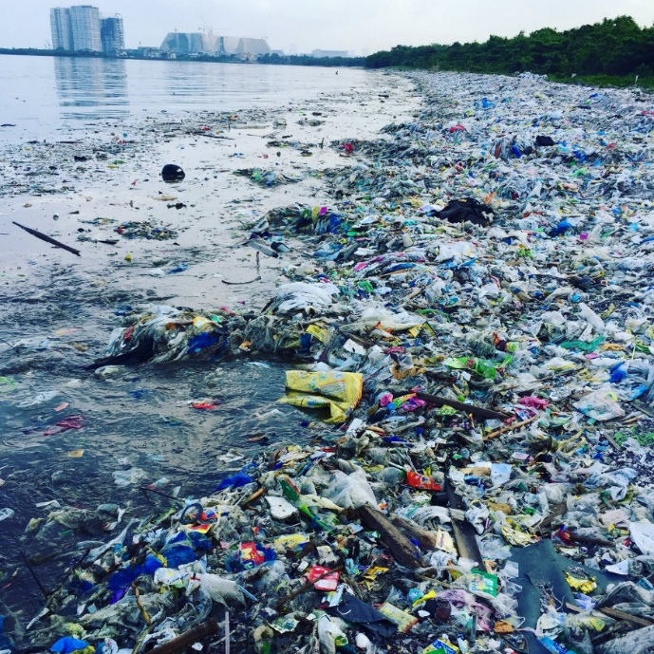

Trash of all kind infesting the shores of cities

Plastic and trash floating a top the surface of the ocean

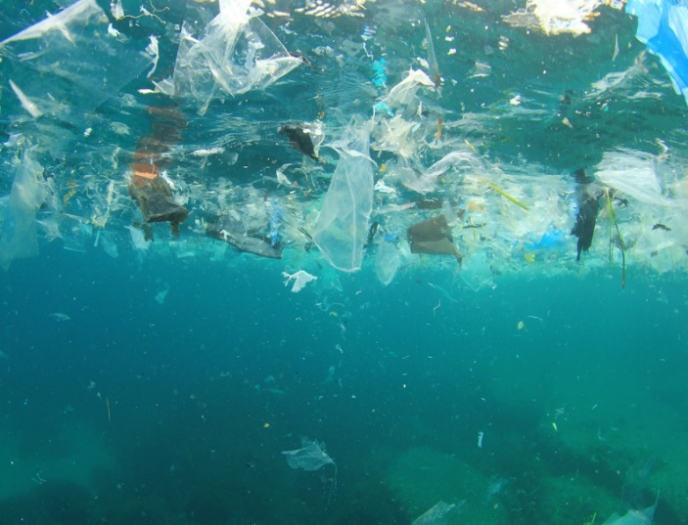

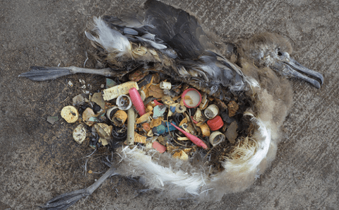

Bird mistakenly eating the trash they see such as plastic caps as their food

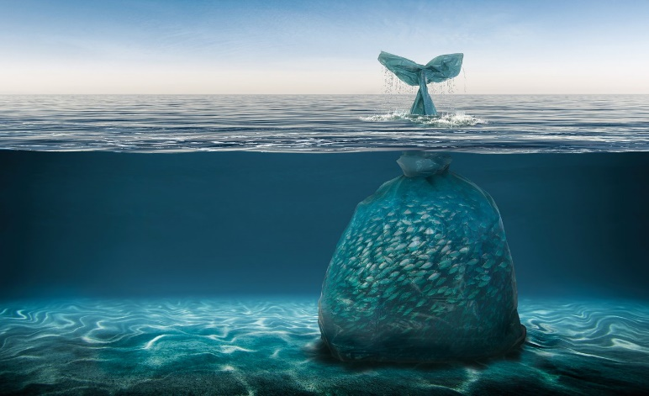

A picture portraying how the new sea animals are trash. You see the tail of a whale, but it is the knot of the garbage bag.

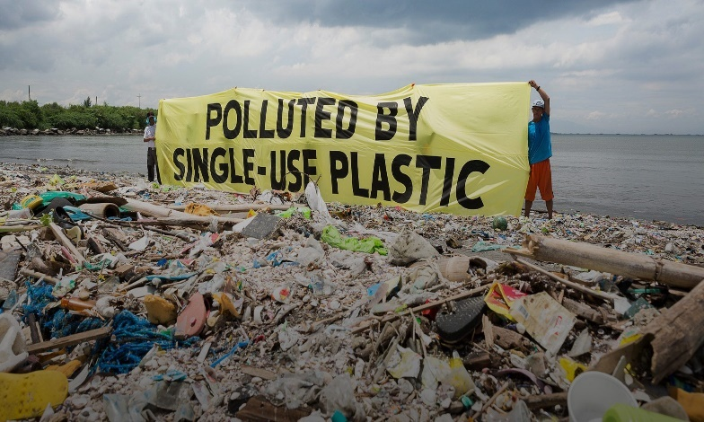

Villagers make a poster to show how their beaches are trashed with single use plastic that is not easy to break down.

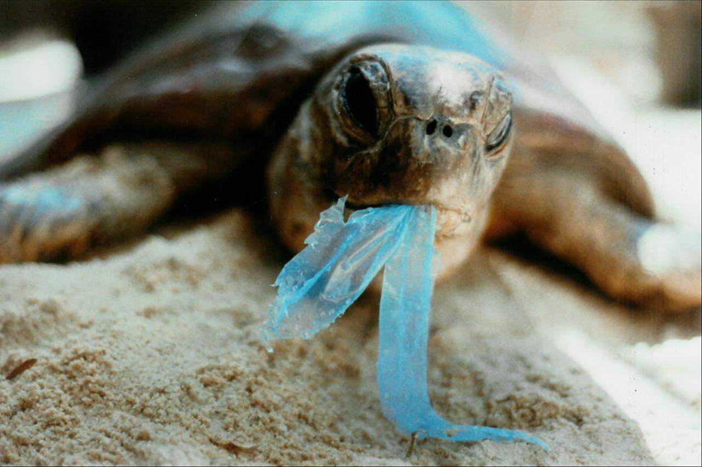

Sea turtle eating a piece of plastic bag

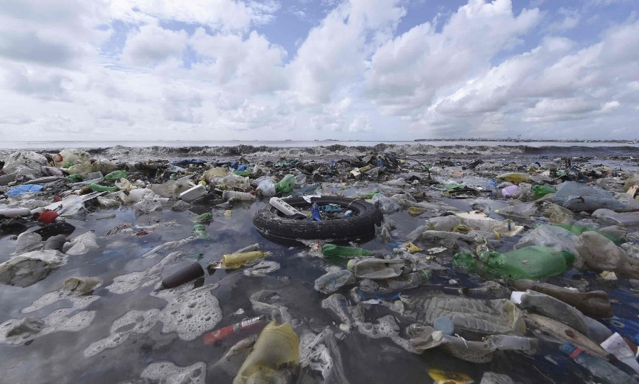

The Great Pacific Garbage Patch is shown with all sorts of garbage floating

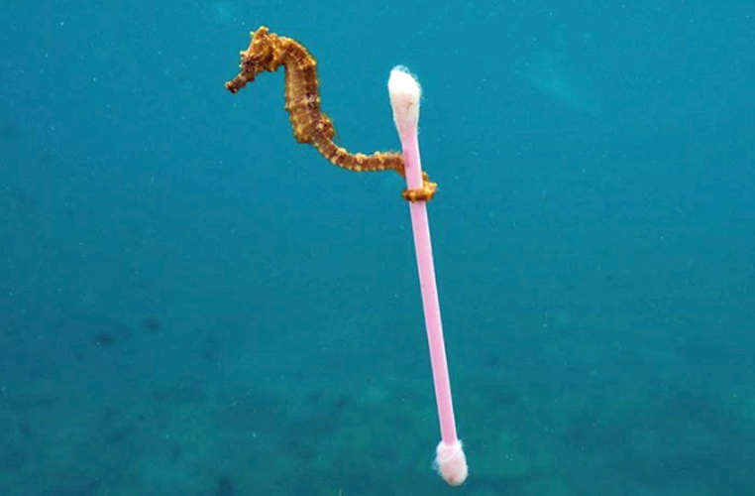

This image of a seahorse carrying a cotton swab had become viral showing marine life affect to this garbage